Lab 10

**1. Write a function in python to read the content from a text file "ABC.txt line by line and display the same on screen.**

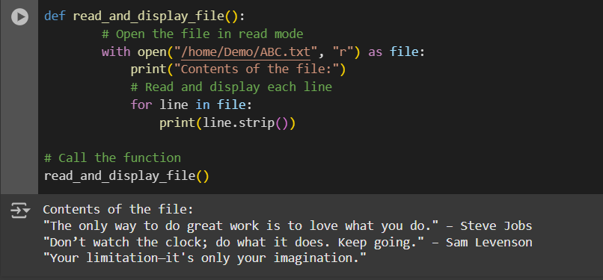

**2. Write a function in Python to count and display the total number of words in a text file “ABC.txt”**

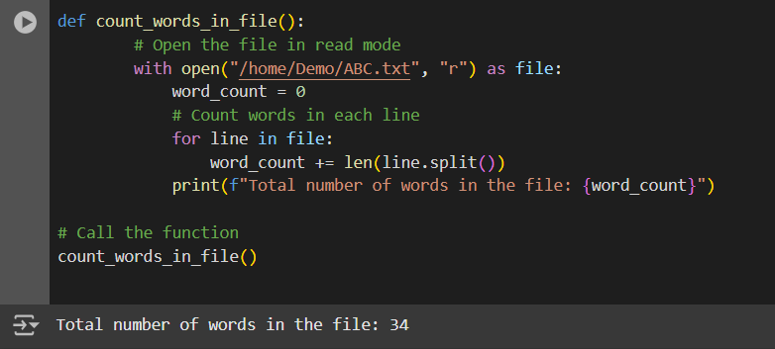

**3. Write a function in Python to count uppercase character in a text file “ABC.txt”**

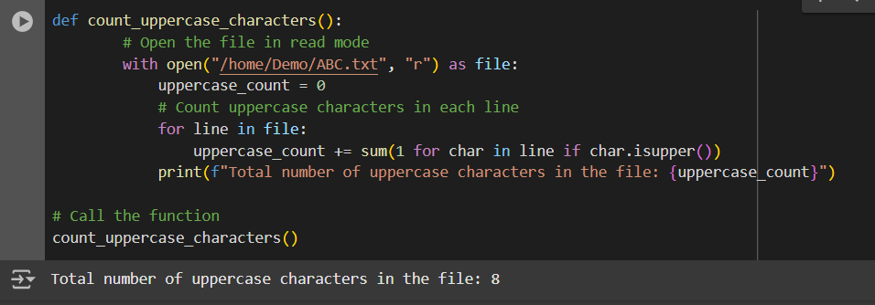

**4. Write a function display_words() in python to read lines from a text file "story.txt", and display those words, which are less than 4 characters.**

